|  |  |  |
| --- | --- | --- |
| **LAB 321 Assignment** | **Type:** | **Long Assignment** |
| **Code:** | **J3.L.P0001** |
| **LOC:** | **200** |
| **Slot(s):** | **8** |

**Title:** Online Quiz

**Background**

You often see and use the online test or quiz, it can be found easily on internet, training center, academy or even a school. In this assignment, you will learn how to build an online quiz system, particular system including the module for administrator (manager) uses to import/manage the question bank and user information, other module for taken test.

**Program Specifications**

Program an online quiz, detail functions of this website is described below

**Features:**

This website contains 5 main functions, we have two kind of users: Teacher and normal user.

As the teacher you are allowed to use all functions of system, for Manage Quiz – you only can see your created questions only.

As the Student you are allowed to use function 1, 2 and 5 only.

* Function 1 : Home page : ( see figure 01)
  + There for menu on navigation bar: Home (current page), Take Quiz, Make Quiz, Manage Quiz and Contact
  + To be able to use the function of each menu, users are required to login the system first. If you wish to have an account, you can make a new one by click on hyperlink Register
* Function 2 : Take Quiz page ( see PIC 02)
  + Select the number of questions and start the quiz
  + Assume that the time allowance for a question is 01 (one) minute
  + Calculate and print the score for taker
* Function 3: Make Quiz ( see PIC 03)
  + Enter information of a Quiz and save it to your database
* Function 4: Manage Quiz ( see PIC 04)
  + Display information of all questions
* Function 5: Register a new user ( see PIC 05)
  + Register a new user
  + A new user and be a teacher or normal user

Note: All data must be load from database, not hard code.

***Expectation of User interface:***

Pic 01: Home Page ( TOP)

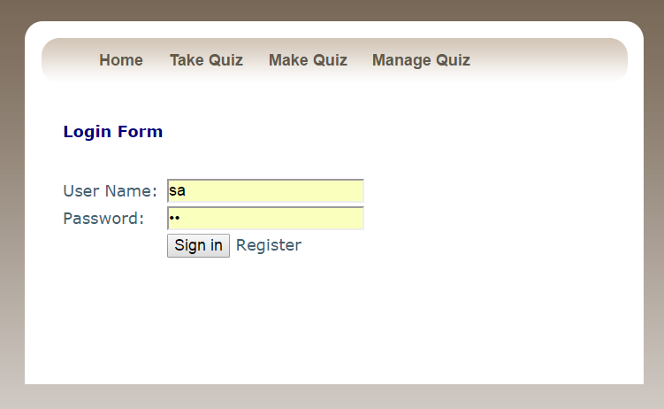

PIC 02: Take Quiz Page

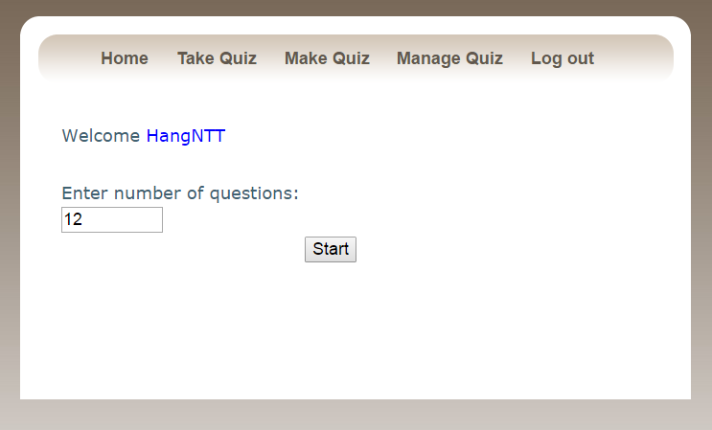

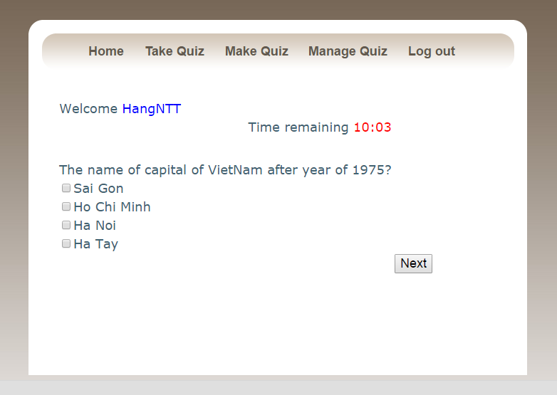

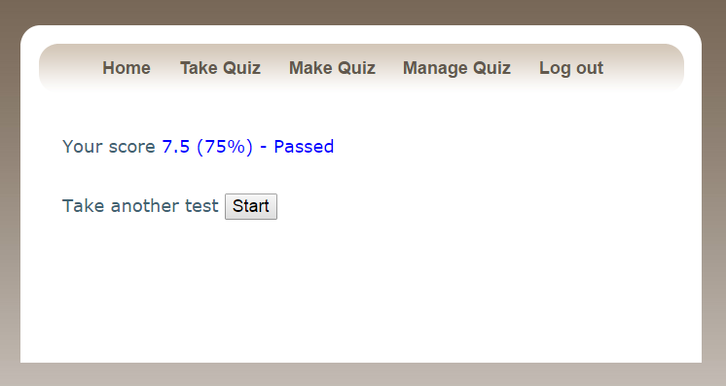

Pic 03: Make quiz page

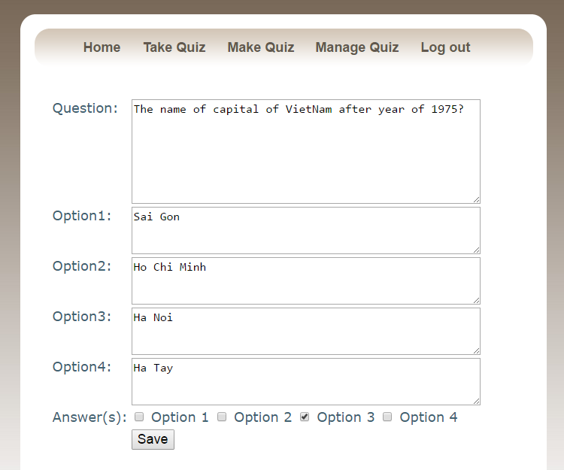

PIC 4: Manage Quiz Page

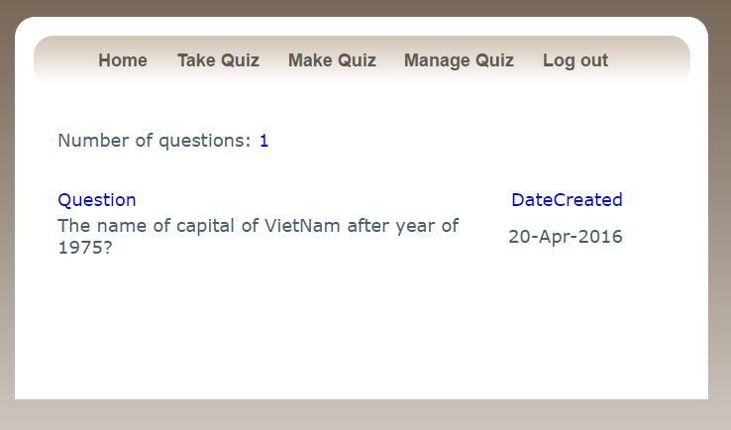

PIC 05: Register Page

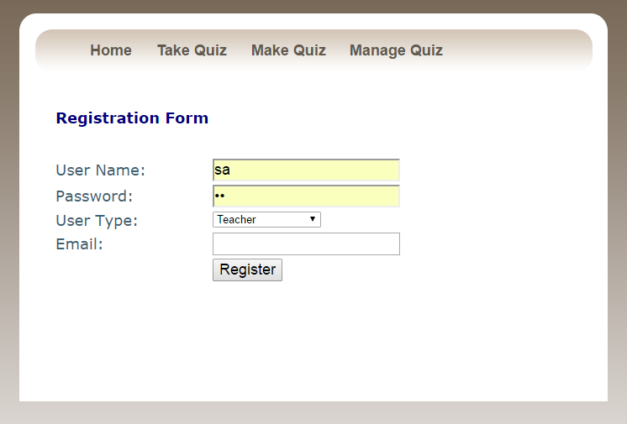

**Guidelines**

* Step 1 : Create prototype
* Step 2 : Design database base on created prototype
* Step 3 : Code & Test